Week 8: Jenkins Automation
- Hands-on practice on manual creation of Jenkins pipeline using Maven projects from Github
- Create the job and build the pipeline for maven-java and maven-web project.
- Questions on Jenkins
- Upload the Screenshots.

- Steps for MavenJava Automation:
Maven Java Automation Steps:
Step 1: Open Jenkins (localhost:8080)
├── Click on "New Item" (left side menu
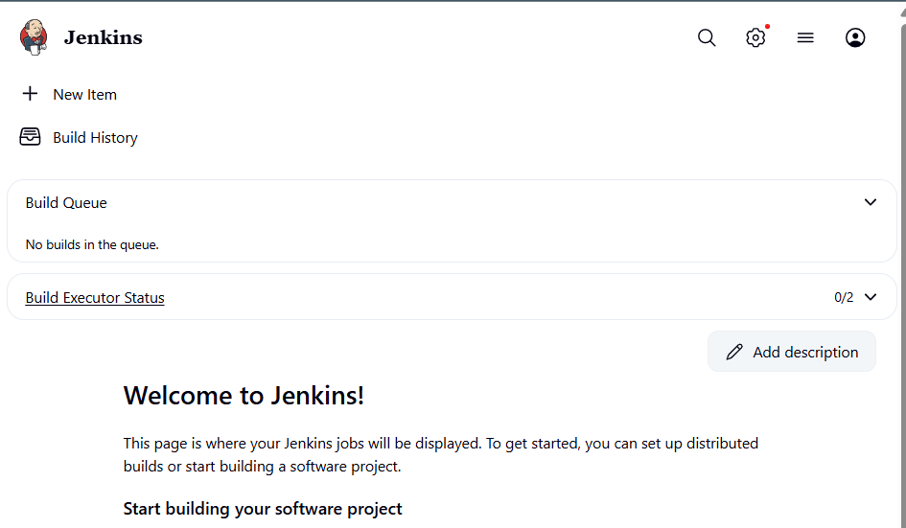
Step 2: Create Freestyle Project (e.g., MavenJava_Build)
├── Enter project name (e.g., MavenJava_Build)
├── Click "OK"
└── Configure the project:
├── Description: "Java Build demo"
├── Source Code Management:
└── Git repository URL: [GitMavenJava repo URL]
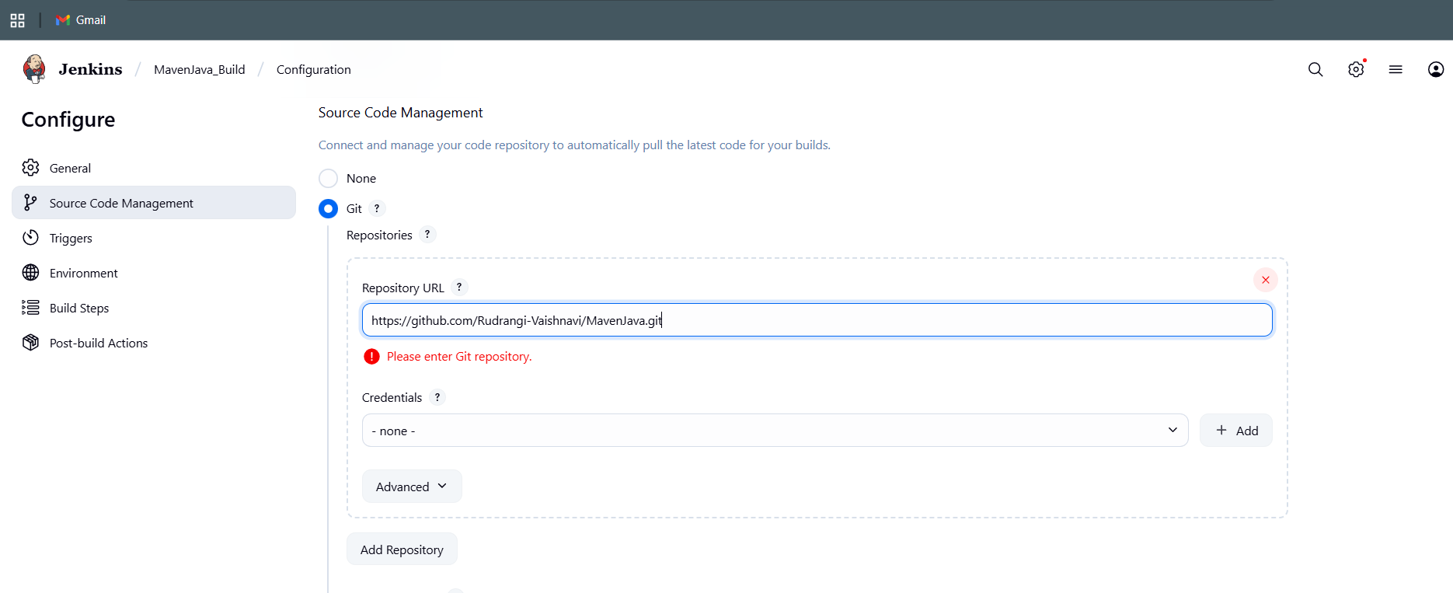
├── Branches to build: */Main or */master
└── Build Steps:
├── Add Build Step -> "Invoke top-level Maven targets"
└── Maven version: MAVEN_HOME
└── Goals: clean
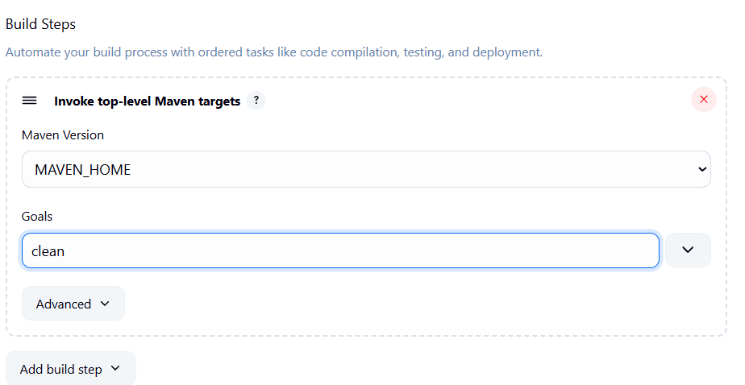
├── Add Build Step -> "Invoke top-level Maven targets"
└── Maven version: MAVEN_HOME
└── Goals: install
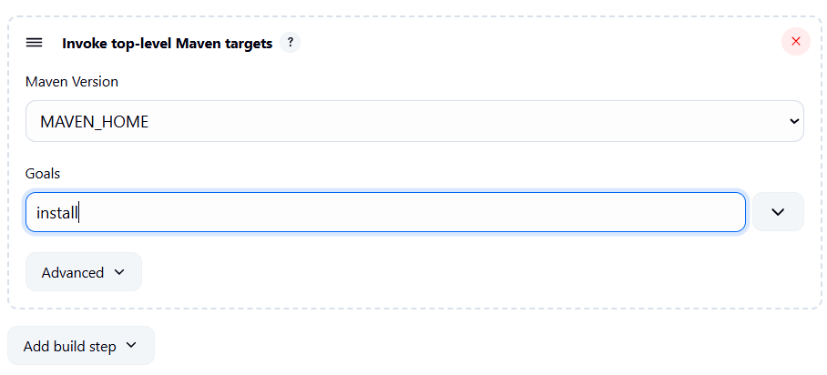
└── Post-build Actions:
├── Add Post Build Action -> "Archive the artifacts"
└── Files to archive: **/*
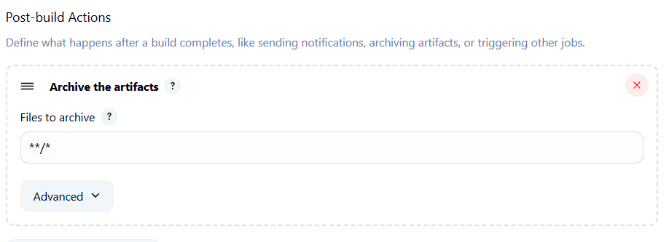
├── Add Post Build Action -> "Build other projects"
└── Projects to build: MavenJava_Test
└── Trigger: Only if build is stable
└── Apply and Save

└── Step 3: Create Freestyle Project (e.g., MavenJava_Test)
├── Enter project name (e.g., MavenJava_Test)
├── Click "OK"
└── Configure the project:
├── Description: "Test demo"
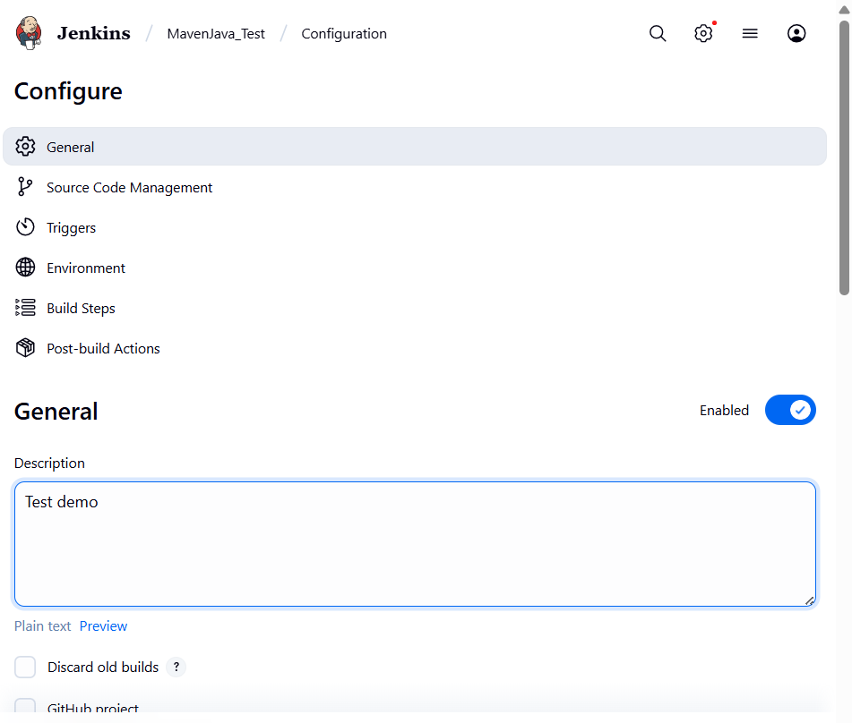
├── Build Environment:
└── Check: "Delete the workspace before build starts"
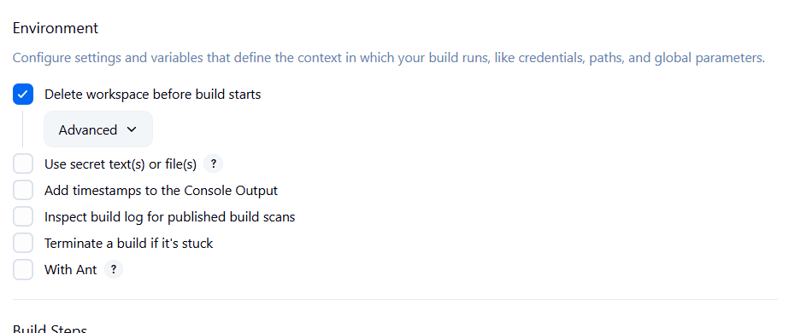
├── Add Build Step -> "Copy artifacts from another project"
└── Project name: MavenJava_Build
└── Build: Stable build only // tick at this
└── Artifacts to copy: **/*
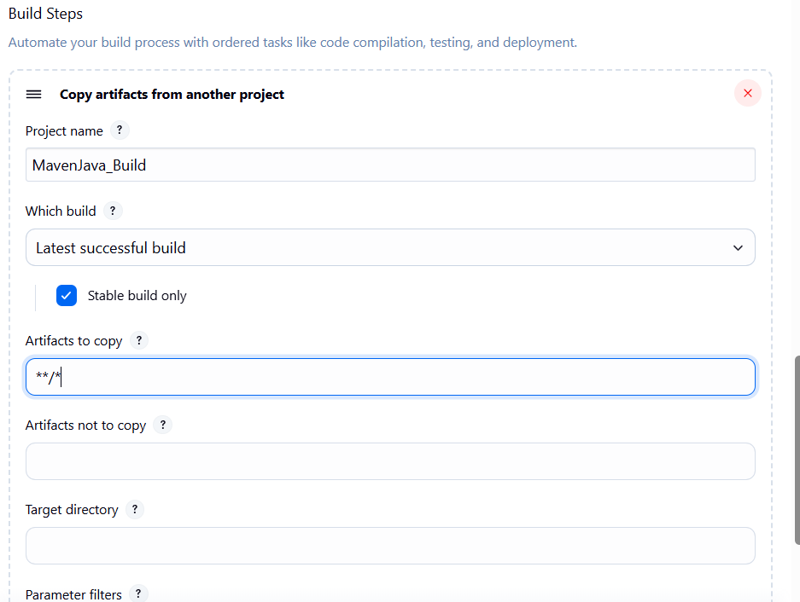
├── Add Build Step -> "Invoke top-level Maven targets"
└── Maven version: MAVEN_HOME
└── Goals: test
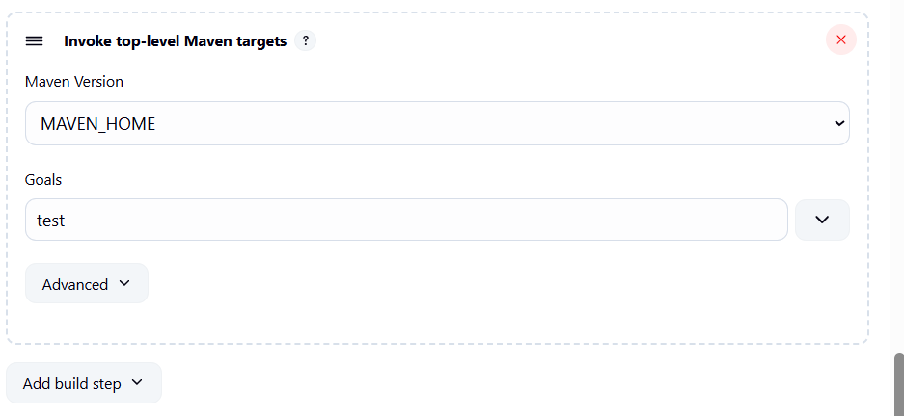
├── Add Post Build Action -> "Archive the artifacts"
└── Files to archive: **/*
└── Apply and Save
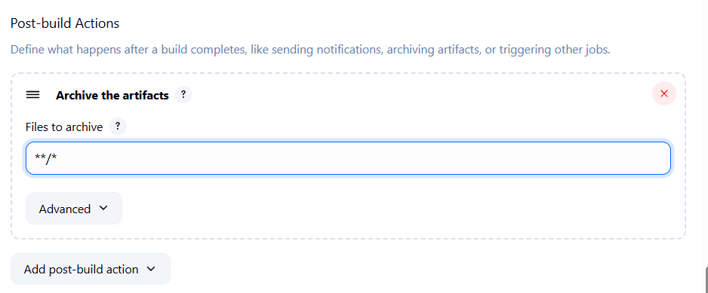
└── Step 4: Create Pipeline View for Maven Java project
├── Click "+" beside "All" on the dashboard
├── Enter name: MavenJava_Pipeline
├── Select "Build pipeline view" // tick here
|--- create
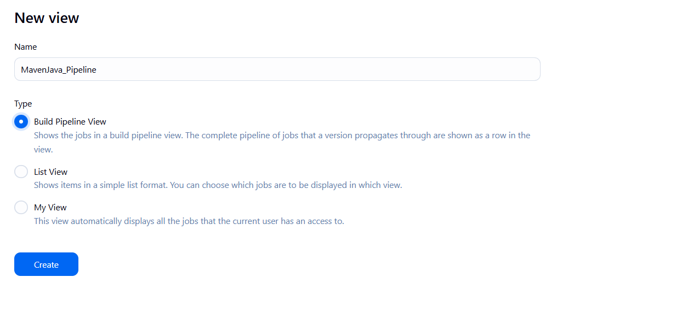
└── Pipeline Flow:
├── Layout: Based on upstream/downstream relationship
├── Initial job: MavenJava_Build
└── Apply and Save OK
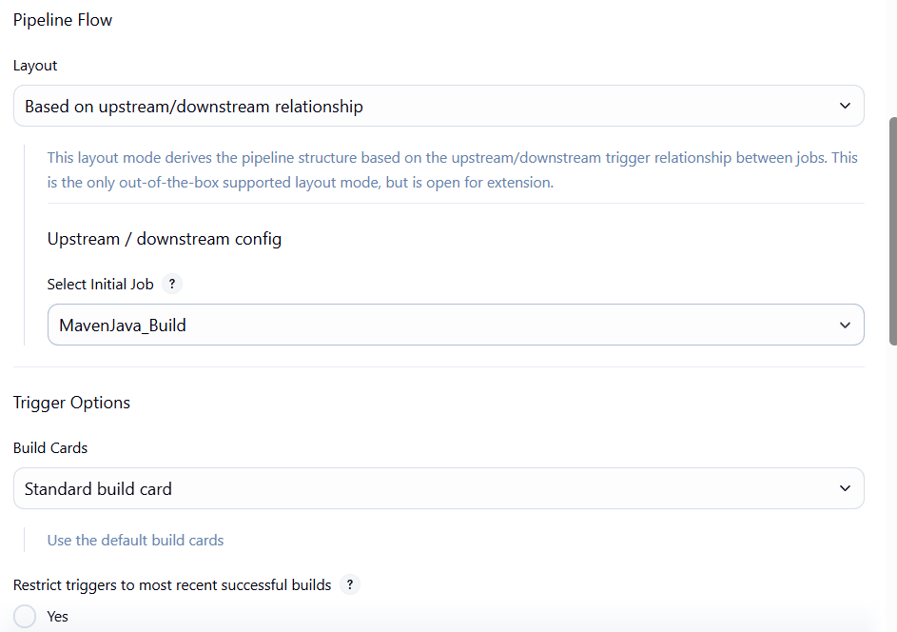
└── Step 5: Run the Pipeline and Check Output
├── Click on the trigger to run the pipeline
├── click on the small black box to open the console to check if the build is success
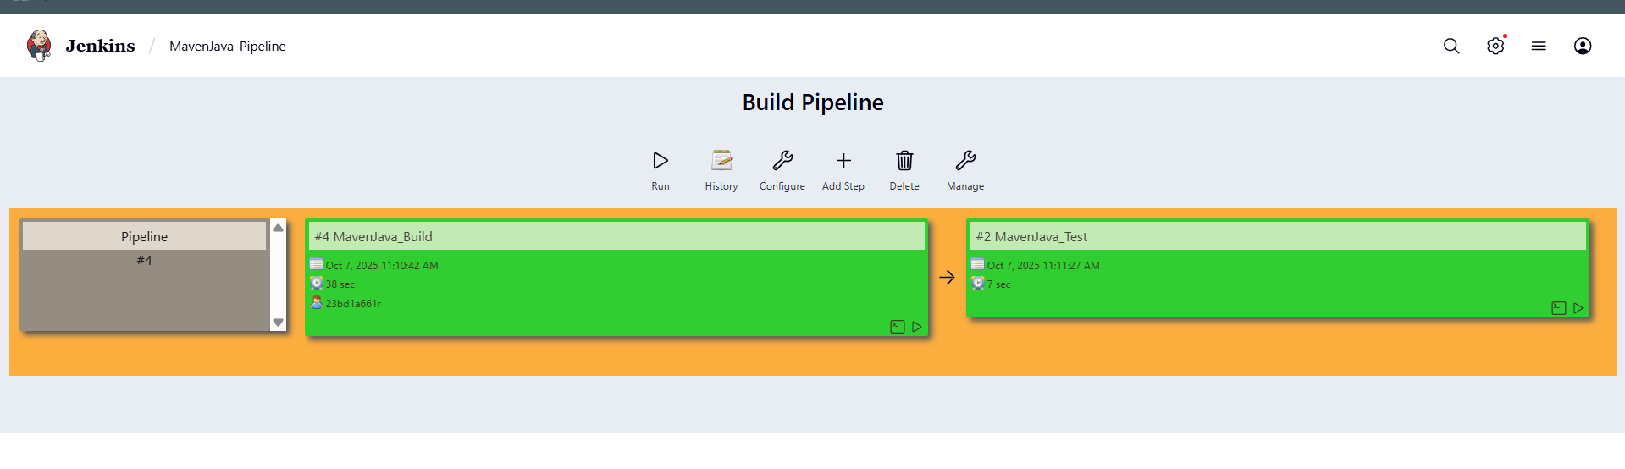
Note :
- If build is success and the test project is also automatically triggered with name
“MavenJava_Test”
- The pipeline is successful if it is in green color as shown ->check the console of the test project
- The test project is successful and all the artifacts are archived successfully
II. Maven Web Automation Steps:
└── Step 1: Open Jenkins (localhost:8080)
├── Click on "New Item" (left side menu)

└── Step 2: Create Freestyle Project (e.g., MavenWeb_Build)
├── Enter project name (e.g., MavenWeb_Build)
├── Click "OK"
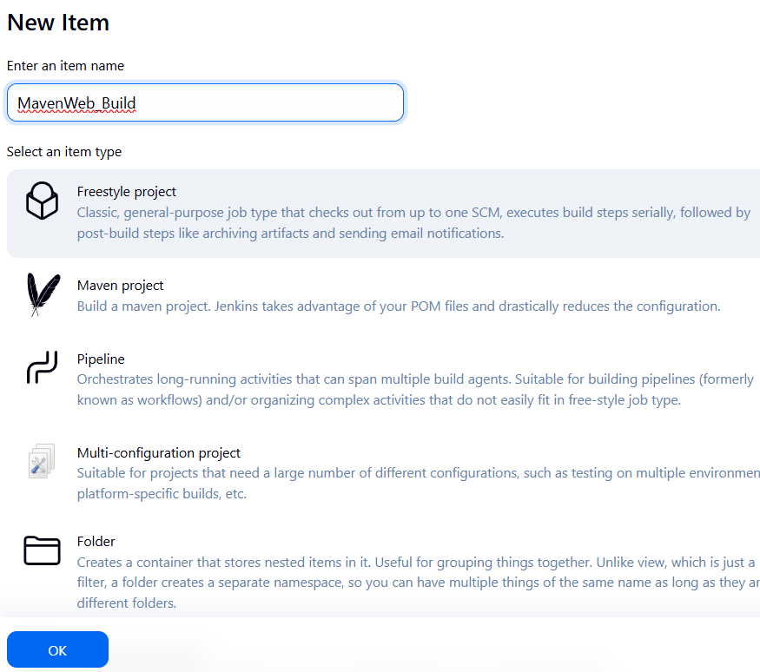
└── Configure the project:
├── Description: "Web Build demo"
├── Source Code Management:
└── Git repository URL: [GitMavenWeb repo URL]
├── Branches to build: */Main or master
└── Build Steps:
├── Add Build Step -> "Invoke top-level Maven targets"
└── Maven version: MAVEN_HOME
└── Goals: clean
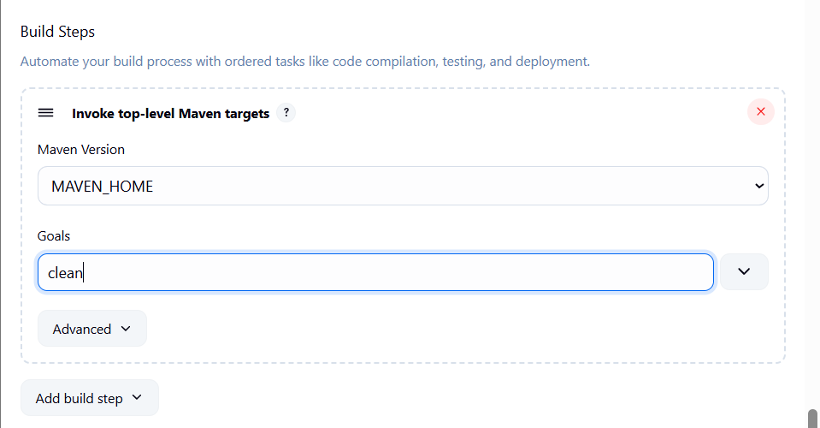
├── Add Build Step -> "Invoke top-level Maven targets"
└── Maven version: MAVEN_HOME
└── Goals: install
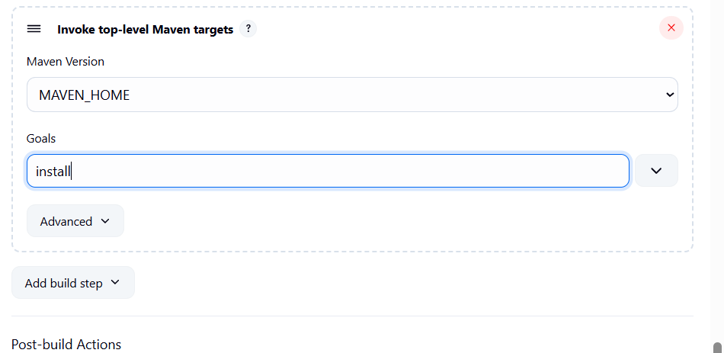
└── Post-build Actions:
├── Add Post Build Action -> "Archive the artifacts"
└── Files to archive: **/*
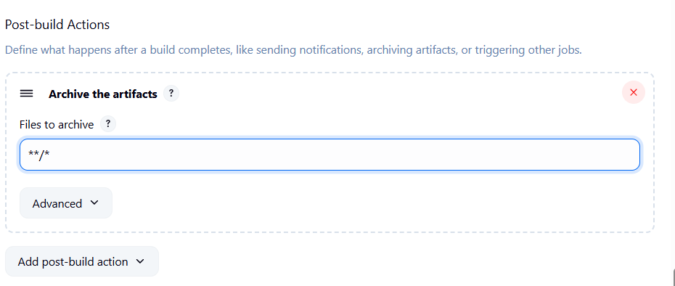
├── Add Post Build Action -> "Build other projects"
└── Projects to build: MavenWeb_Test
└── Trigger: Only if build is stable
└── Apply and Save
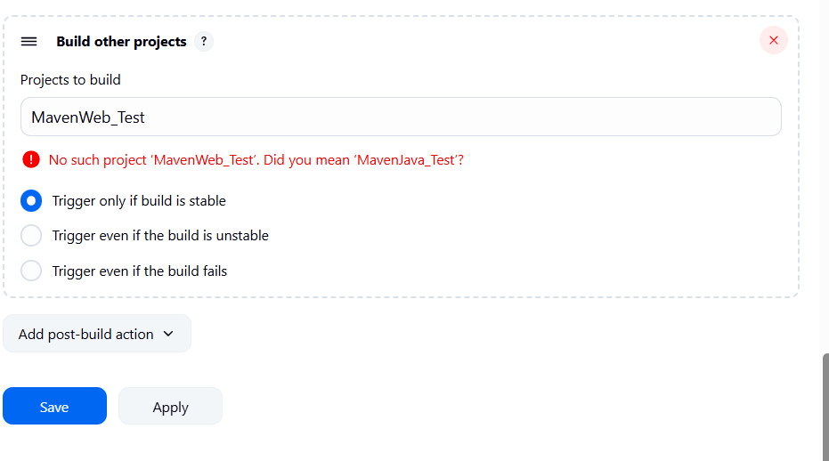
└── Step 3: Create Freestyle Project (e.g., MavenWeb_Test)
├── Enter project name (e.g., MavenWeb_Test)
├── Click "OK"
└── Configure the project:
├── Description: "Test demo"
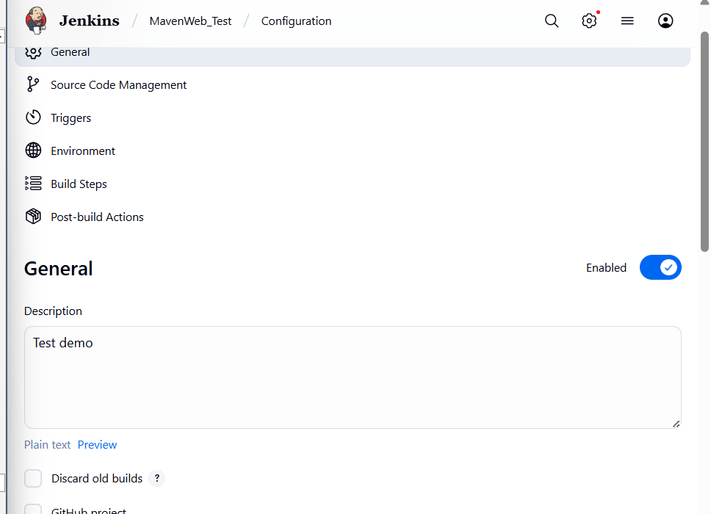
├── Build Environment:
└── Check: "Delete the workspace before build starts"
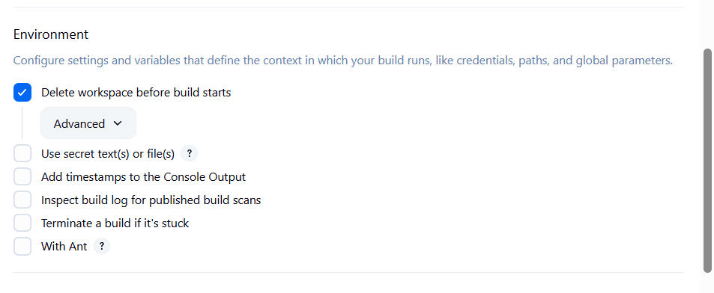
├── Add Build Step -> "Copy artifacts from another project"
└── Project name: MavenWeb_Build
└── Build: Stable build only
└── Artifacts to copy: **/*
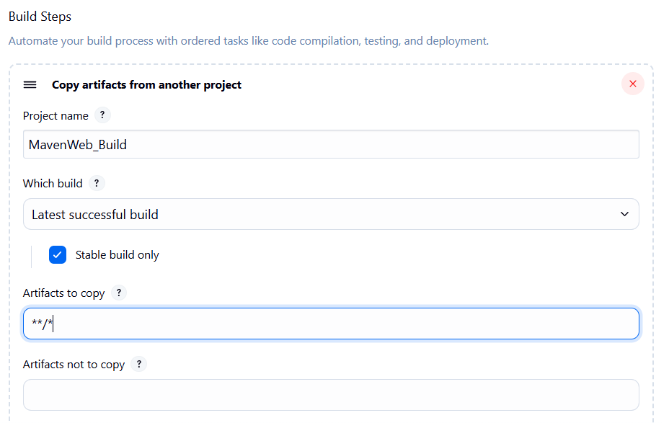
├── Add Build Step -> "Invoke top-level Maven targets"
└── Maven version: MAVEN_HOME
└── Goals: test
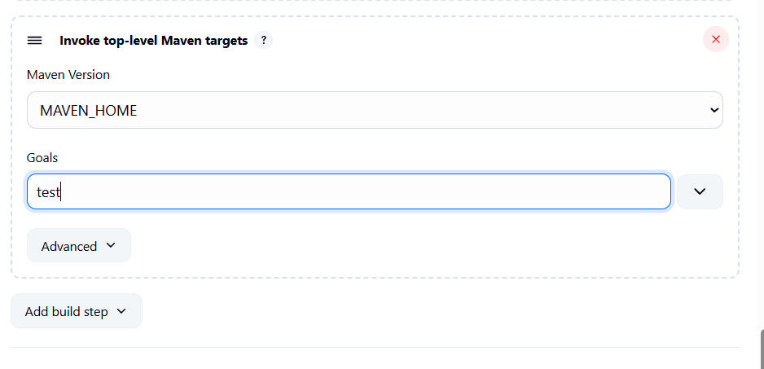
└── Post-build Actions:
├── Add Post Build Action -> "Archive the artifacts"
└── Files to archive: **/*
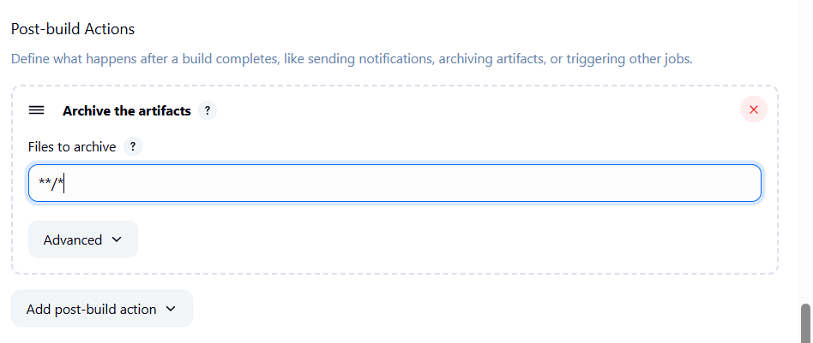
├── Add Post Build Action -> "Build other projects"
└── Projects to build: MavenWeb_Deploy
└── Apply and Save
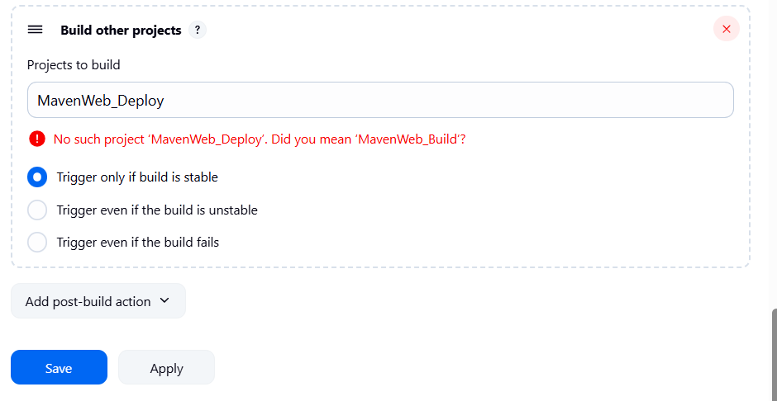
└── Step 4: Create Freestyle Project (e.g., MavenWeb_Deploy)
├── Enter project name (e.g., MavenWeb_Deploy)
├── Click "OK"
└── Configure the project:
├── Description: "Web Code Deployment"
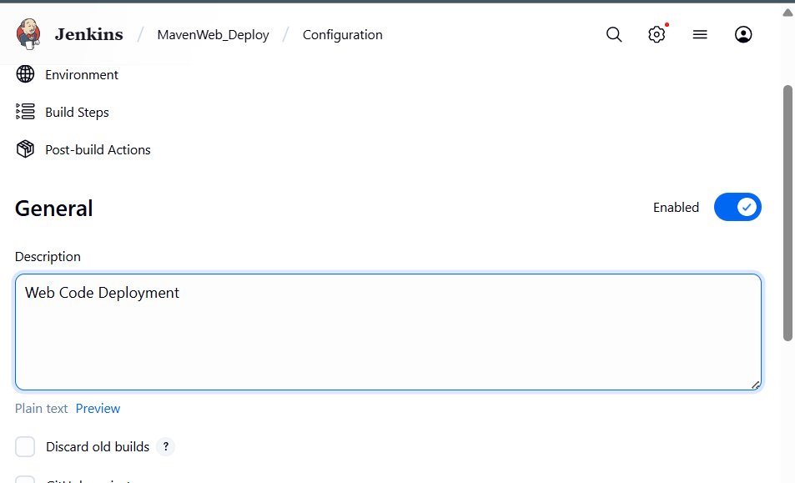
├── Build Environment:
└── Check: "Delete the workspace before build starts"
├── Add Build Step -> "Copy artifacts from another project"
└── Project name: MavenWeb_Test
└── Build: Stable build only
└── Artifacts to copy: **/*
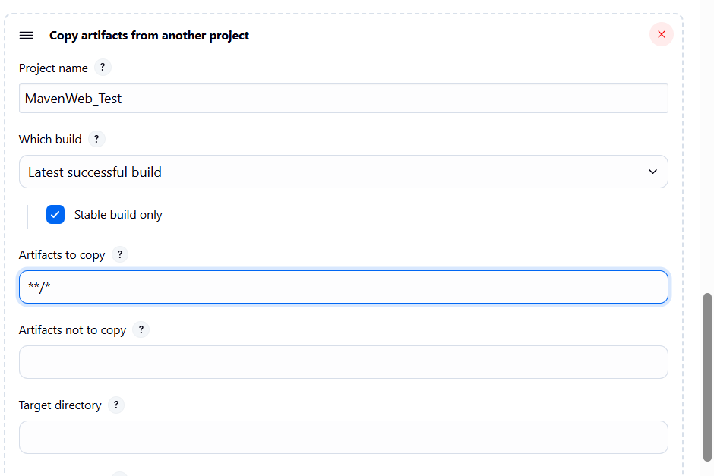
└── Post-build Actions:
├── Add Post Build Action -> "Deploy WAR/EAR to a container"
└── WAR/EAR File: **/*.war
└── Context path: Webpath
└── Add container -> Tomcat 9.x remote
└── Credentials: Username: admin, Password: 1234
── Tomcat URL: https://localhost:8085/
└── Apply and Save

└── Step 5: Create Pipeline View for MavenWeb
├── Click "+" beside "All" on the dashboard
├── Enter name: MavenWeb_Pipeline
├── Select "Build pipeline view"
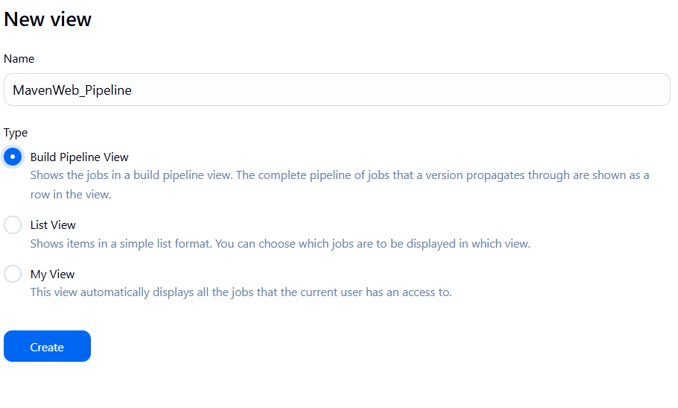
└── Pipeline Flow:
├── Layout: Based on upstream/downstream relationship
├── Initial job: MavenWeb_Build
└── Apply and Save
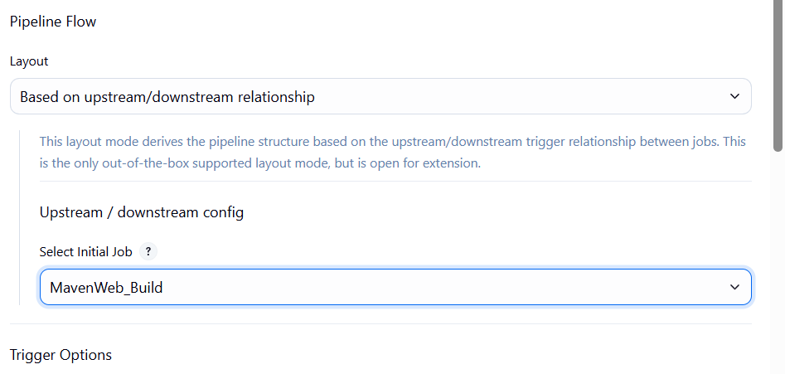

└── Step 6: Run the Pipeline and Check Output
├── Click on the trigger “RUN” to run the pipeline
Note:
- After Click on Run -> click on the small black box to open the console to check if the build is success
- Now we see all the build has success if it appears in green color
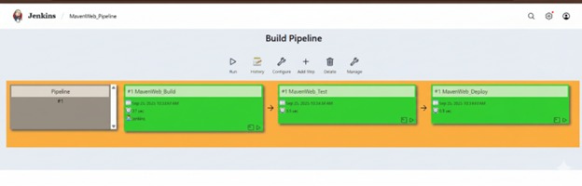
├── Open Tomcat homepage in another tab
├── Click on the "/webpath" option under the manager app
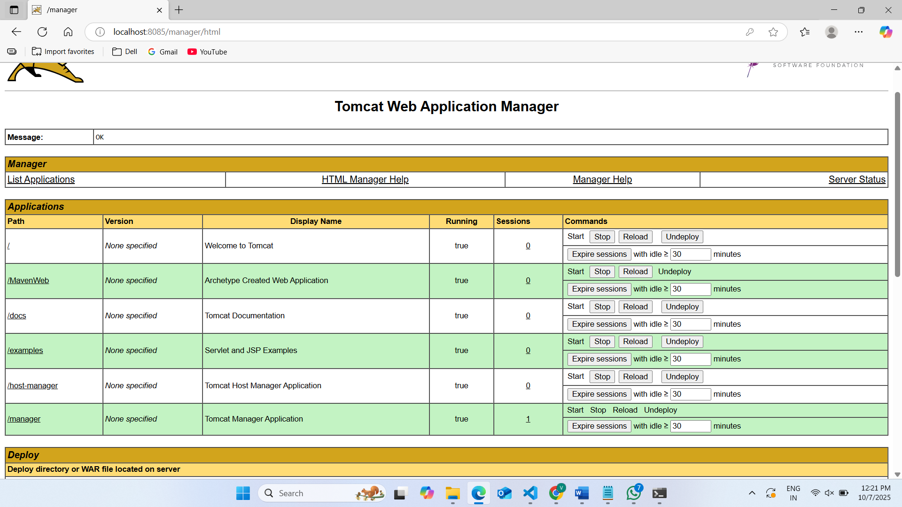
Note:
- It ask for user credentials for login ,provide the credentials of tomcat.
- It provide the page with out project name which is highlighted.
- After clicking on our project we can see output.

- Questions on Jenkins
- What is Jenkins primarily used for?
- Jenkins is used for Continuous Integration and Continuous Deployment (CI/CD) — automating build, test, and deployment processes.

- What is feature of Jenkins?
- Jenkins is open-source, extensible with plugins, supports pipeline automation, and integrates with many tools (Git, Docker, etc.).

- What is the default port on which Jenkins runs?
- Port 8080.

- What can be integrated with Jenkins for version control?
- Git, GitHub etc

- What is the purpose of Jenkins plugins?
A. Plugins extend Jenkins functionality
- Which type of Jenkins job is best suited for running one-off tasks or small scripts?
- Freestyle Project

- How can you manage sensitive information such as API keys in Jenkins?
- Use Credentials Manager to securely store and access secrets like passwords, tokens, and API keys.

- What does the "blue ocean" feature in Jenkins refer to?
- A modern, user-friendly UI for visualizing and managing Jenkins pipelines.

- What does the "blue ocean" feature in Jenkins refer to?
- A modern, user-friendly UI .

- Which Jenkins component allows for distributed builds across multiple machines?
- Jenkins Master-Agent (Node) Architecture

- List at least five Jenkins plugins that you would consider important for a microservices-based application CI/CD pipeline. Briefly explain the purpose of each plugin.
- Git Plugin - Integrates Jenkins with Git repositories , Pipeline Plugin - Enables code-based CI/CD pipelines, Docker Plugin - Builds and deploys Docker containers.

- Explain the steps you would take to install a plugin in Jenkins through the Jenkins UI. What considerations would you keep in mind regarding plugin compatibility and updates?
- Manage Jenkins->Manage Plugins->open available tab-> search install without restart

- Explain the steps you would take to install a plugin in Jenkins through the Jenkins UI. What considerations would you keep in mind regarding plugin compatibility and updates?
- Manage Jenkins->Manage Plugins->open available tab-> search install without restart.

- After installing a plugin, explain how you would configure it within Jenkins. For example, if you installed the Git Plugin, what steps would you take to set it up for your pipeline?
- Manage Jerkins->Configure System->Find git section-> set the credentials ->choose source code management->git and enter the url, branch

- Discuss common issues that might arise when using Jenkins plugins, such as dependency conflicts or version compatibility problems. How would you troubleshoot these issues?
- Dependency conflicts → update or roll back plugins
Version incompatibility → check Jenkins + plugin versions
Missing dependencies → install required plugins
Conclusion: In this week student learnt automating Maven projects through Jenkins.

